Ideation Phase
Empathize & Discover

Date | 22 February 2026
Team ID | LTVIP2026TMIDS42582
Project Name | Home-Rentals
Maximum Marks | 4 Marks

Empathy Map Canvas – Home Rentals Application
People searching for rental homes, especially students and working professionals relocating to new cities, often feel anxious and overwhelmed during the house-hunting process. They worry about safety, affordability, and whether the listings they see are genuine. With limited time and urgent relocation needs, they want a trustworthy platform that offers transparent pricing and a smooth booking experience.
While searching, users encounter numerous rental advertisements across different websites and brokers, many of which contain incomplete information, outdated photos, or hidden charges that appear later in the process. These inconsistencies make it difficult for them to trust the listings. They frequently compare multiple platforms, contact several property owners to verify details, and seek recommendations from friends or colleagues to avoid scams and bad experiences.
Users often express their needs by saying they want a home near their workplace within their budget and with essential amenities. However, they face several challenges, including fake listings, lack of pricing transparency, time-consuming searches, and poor communication with property owners. These pain points make the rental process stressful and inefficient.
Despite these challenges, users hope to find verified listings, clear rental policies, advanced search filters, and secure communication channels that simplify the booking process. A platform like Home-Rentals addresses these needs by providing accurate property details, transparent pricing, easy search options, and a reliable system that connects renters directly with property owners, ultimately making the rental experience faster, safer, and more convenient.
Example: 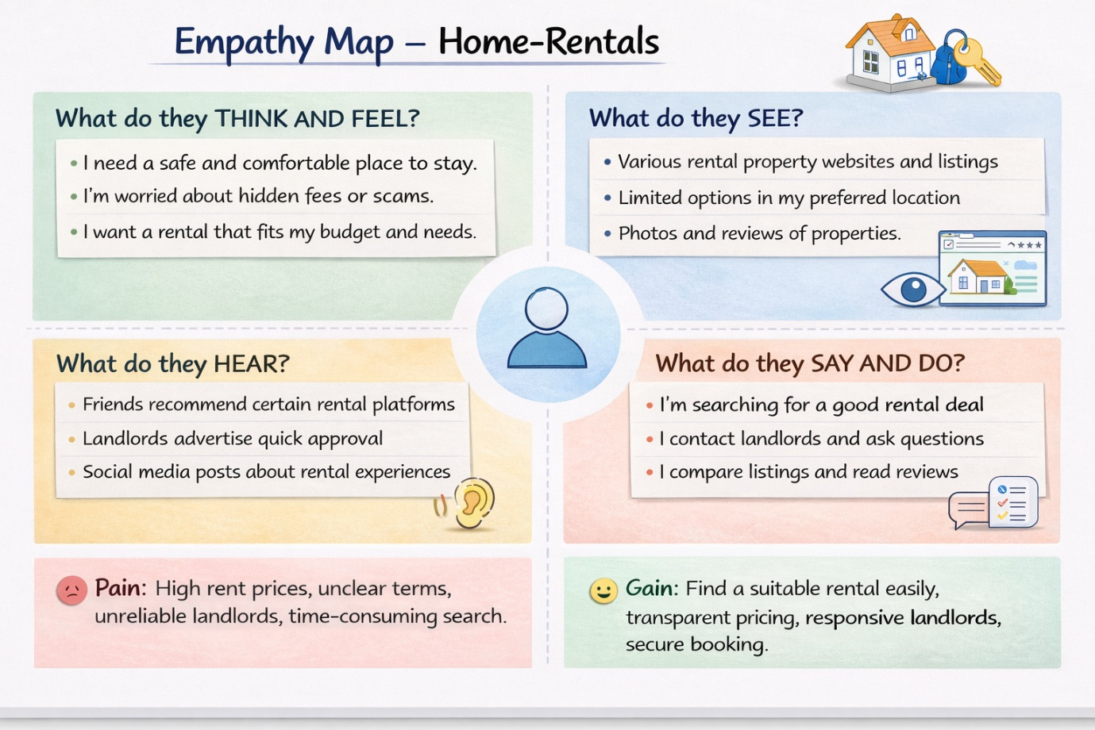

Reference: https://www.mural.co/templates/empathy-map-canvas

Example: Home-Rentals Application
